- Containerization
Containerization is a from of operating system virtualization that allows you to package an application together with all its necessary components .
It solves “it works on my pc” issue which is very common if you give your application code to some one containerization gives isolated environment for the application with all the dependencies needed like python version database version etc. Containers are light weight we can run many at a time.
- Architecture/ Installation
Docker follows client server architecture . User can communicate using docker cli and launch containers or remove containers.docker daemon is the server that manages containers.docker cli is the client.
- Images
Docker image is like a setup which contains complete dependencies of an application like code of the application specific pages to be installed to run the app like python version or java version etc.
There are prebuilt images available on docker hub and we can create our on custom images uisng docker file .
Docker command to view images

Docker command to search available images.
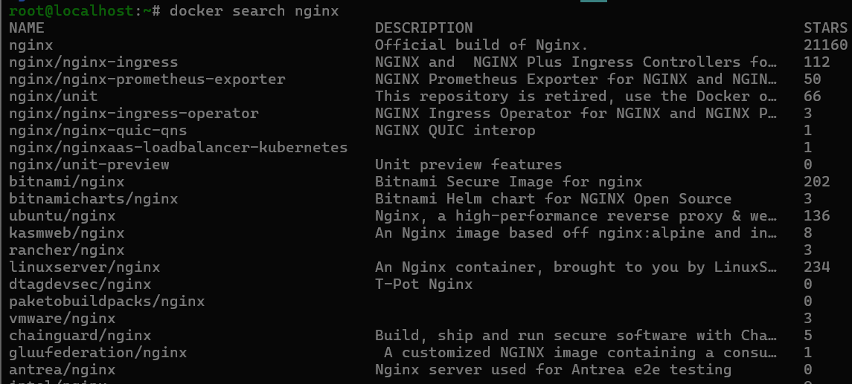
Docker command to pull image

Simple Docker file
In below docker file we make new directory change working dirctory to that now copy index.html filr from outside to inside the container to a specific address now expose port 81
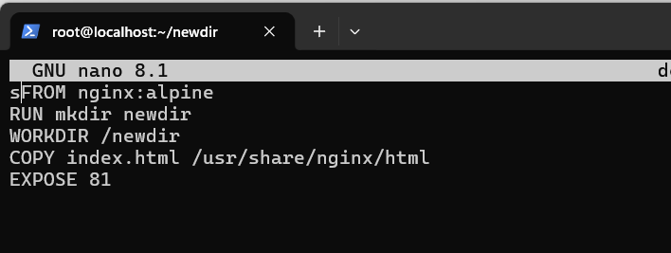
Build image from docker file
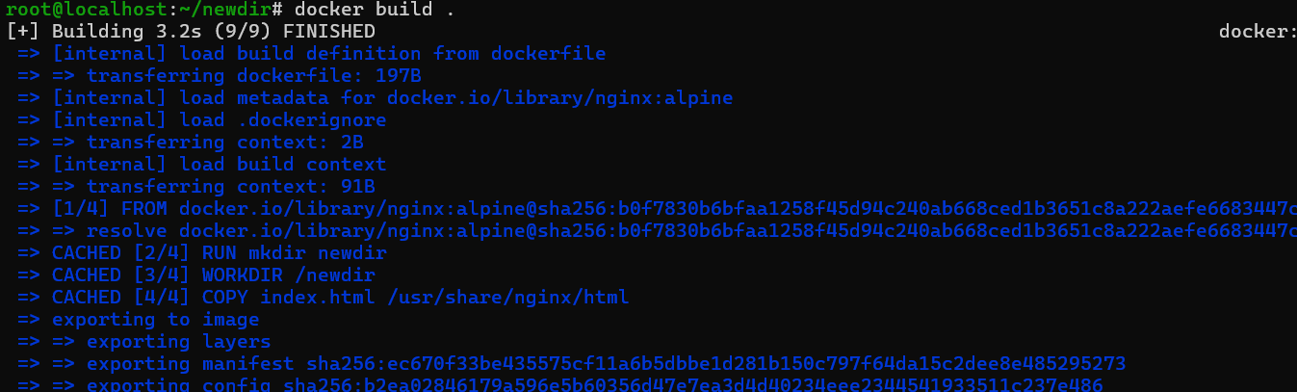
- Voulmes
Docker container when destroyed does not saves any data so to save the data we make a volume and attach it to the docker container so data does not gets destroyed when container is destroyed . One volume can be attached to multiple containers.
Docker volume can be create by command.
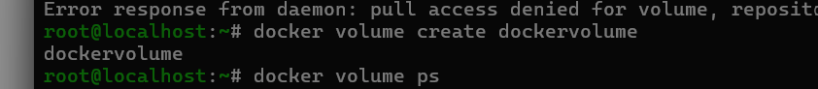
Docker command to view volume
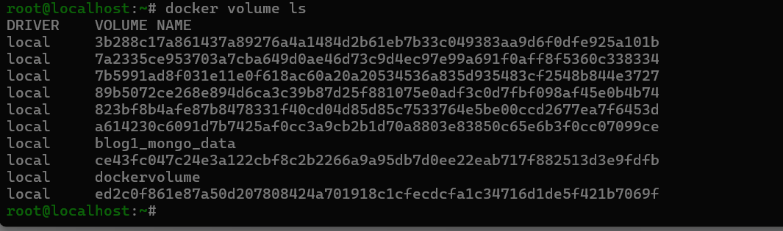
Volume location
/var/lib/volumes/dockervolume
Now attach volumee to container
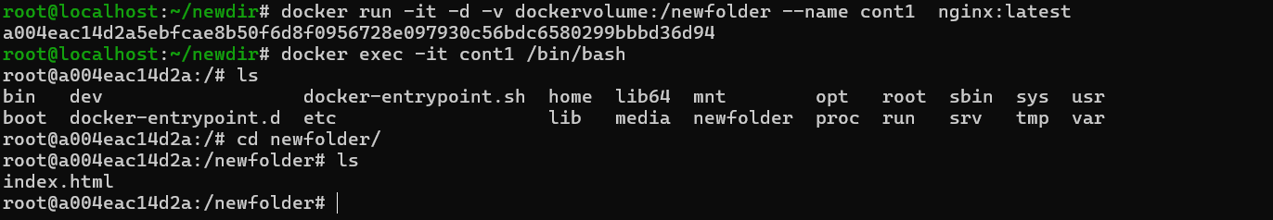
now attach custom folder as volume
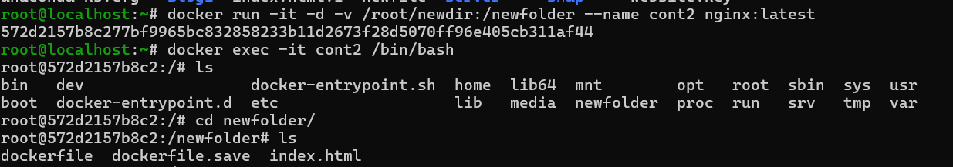
- Networking
Docker by default has some network drivers like bridge host and we can crete our on network using docker create network networkname.By using docker network docker containers cn communicate.
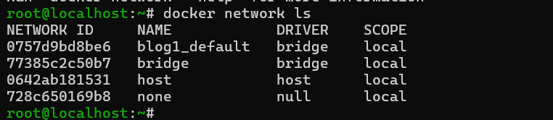
Types of docker network
Bridge
It create a network that is isolated it is only accessible from the host and containers in the same network
Host
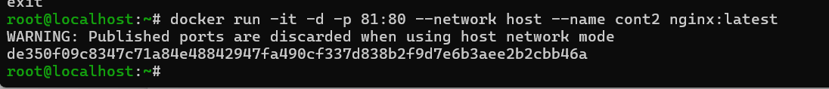
None
Custom
On a Custom Network:
Docker provides a built-in DNS server. If you name your container db-server, any other container on that same custom network can reach it just by using the name db-server. Docker handles the IP mapping behind the scenes.

Max security
- Docker-compose
Docker compose file is used if we want to launch multiple containers at a time we define name network volume port etc all these things in a file we can use base image or build the image from docker file every time we run docker compose up.
Docker compose up command is used to run the container using single command.we can remove all these containers using single command docker compose down.
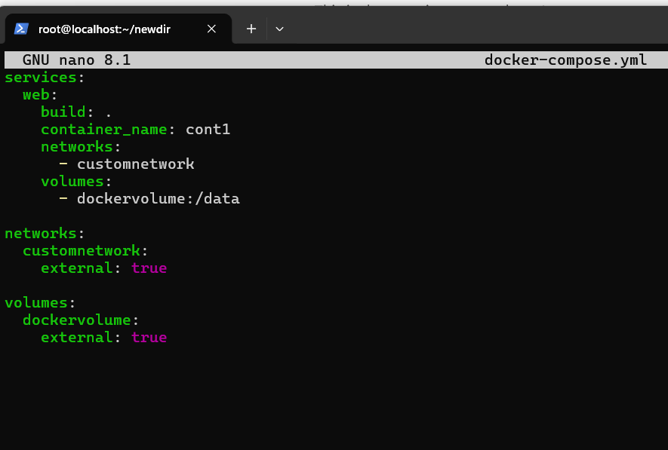

- Docker-Hub
Dockerhub is like git hub but it is used to store images we can tag our builds and push them in our docker hub repository.
To push image on docker hub we tag the image with the username/reponame and tag like username/nginxrepo:customimage
Then login to docker hub using docker login command then by using docker docker push command we can push the image to the repo.
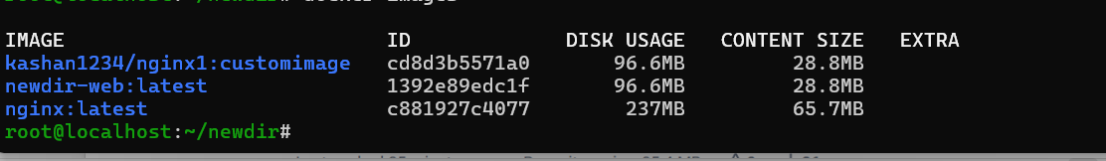
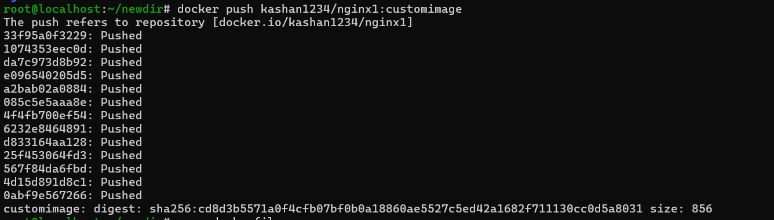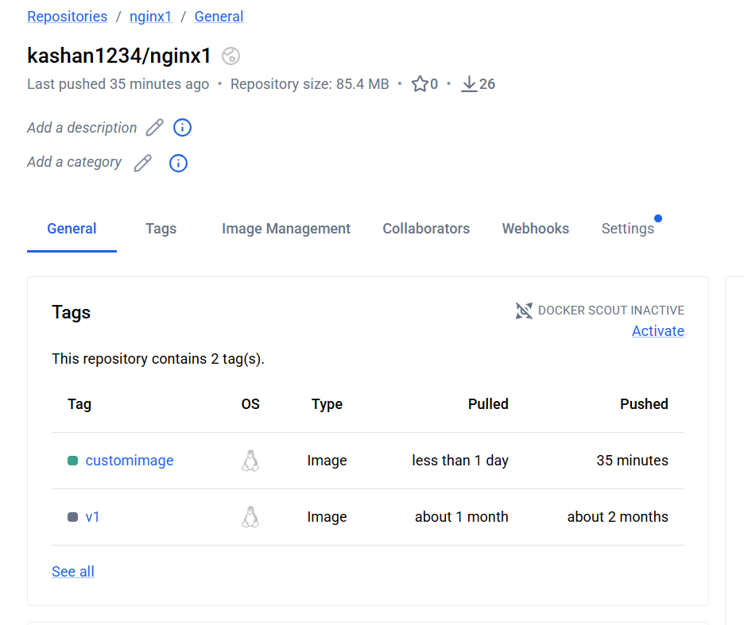
- Troubleshooting
For trobleshooting we can use docker log container name to check the logs of each container we can also use docker inspect command to check details of volume network containr etc.

